**Review 1**

Before:

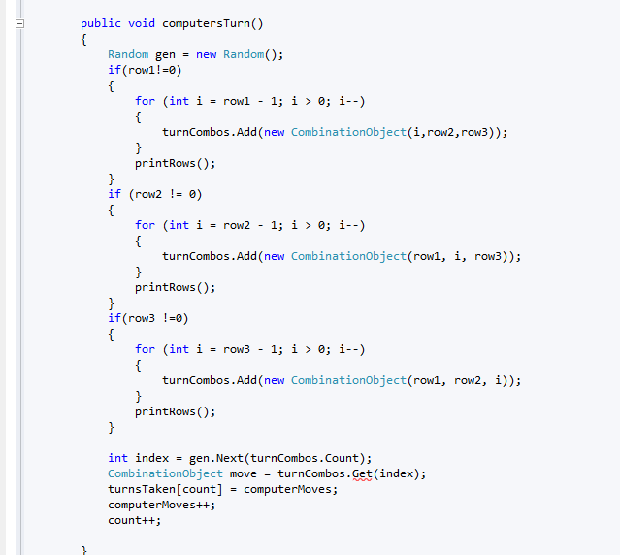

Rule:

Reason:

After